1.Write a javascript to create a single line comment and multi line comment

Code:

<html>

<body>

<h1 id="987"></h1>

<h2 id="123"></h2>

<script>

// change heading:

document.getElementById("987").innerHTML="JAVASCRIPT";

/* here the coding to change the above heading

so, the heading 987to the new headline

the new headline is given as my first program */

document.getElementById("123").innerHTML="html";

</script>

</body>

</html>

Output:

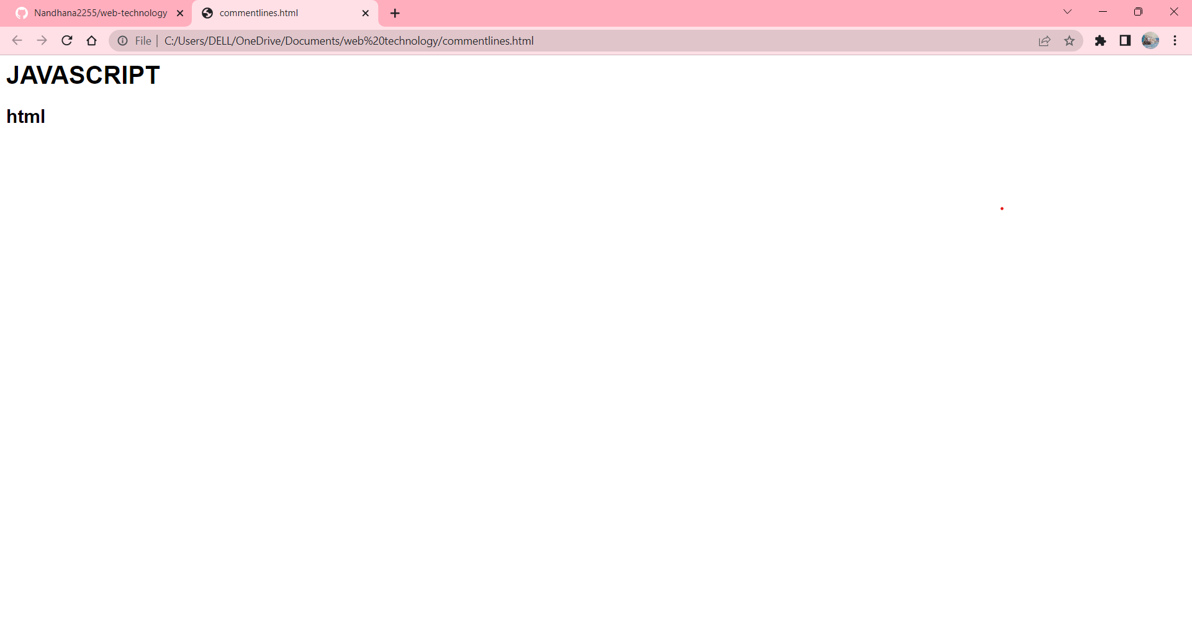

2.write a javascript to convert the first letter of the string into uppercase

Code:

<html>

<body>

<h1>Make first letter of a string uppercase</h1>

<input type="text" id="input" />

<button onclick="capitalizeFLetter()">Click </button>

<h2 id="out"></h2>

<script>

function capitalizeFLetter() {

var input = document.getElementById("input");

var x = document.getElementById("out");

var string = input.value;

x.innerHTML = string[0].toUpperCase() + string.slice(1);

}

</script>

</body>

</html>

Output:

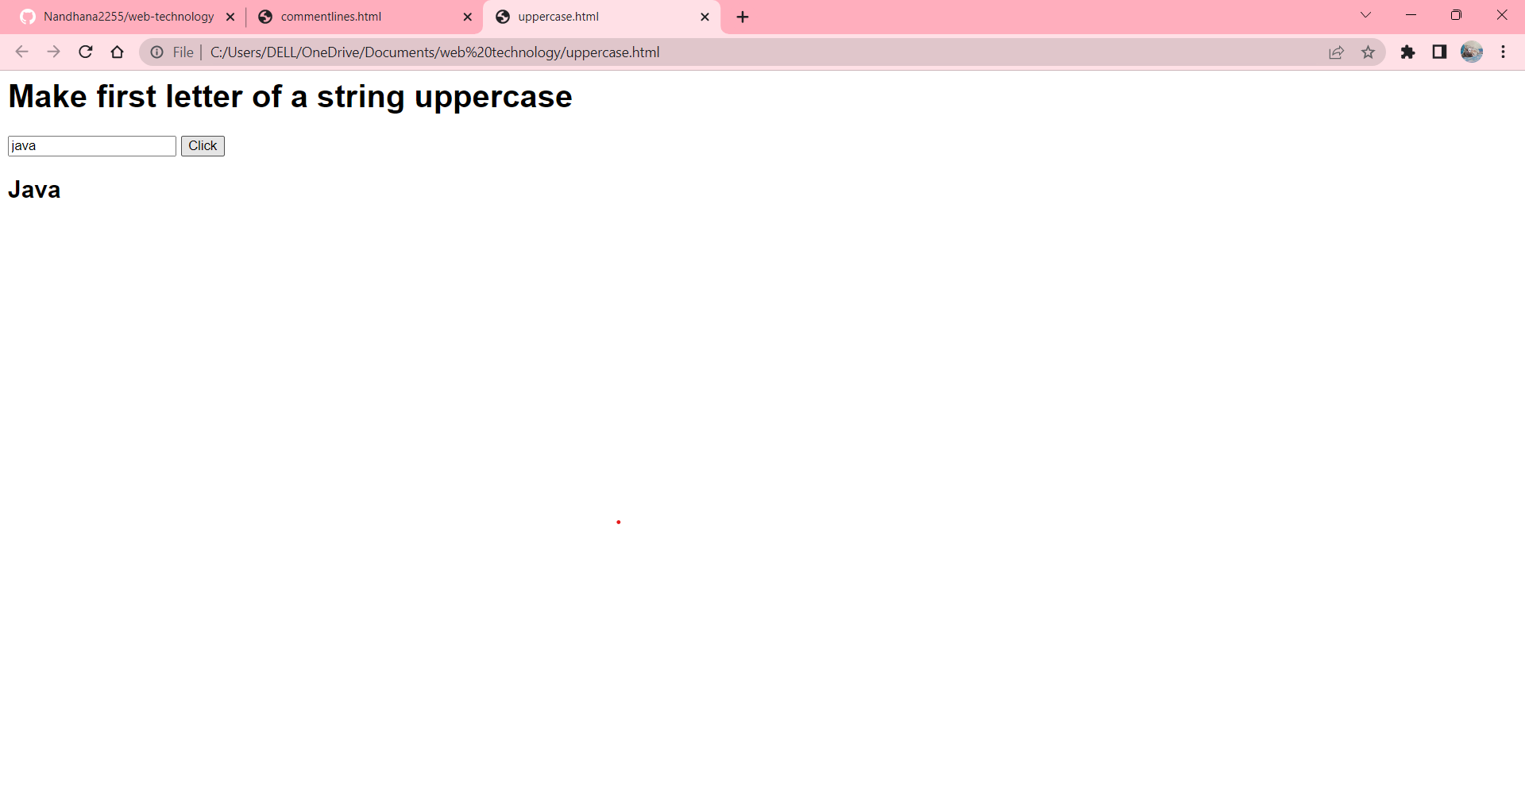

3.write a javascript to receive input from the user then the code gets in action,based on user input

Code:

<html>

<head>

<script>

function jsFun()

{

var valuee, element;

valuee = parseInt(document.getElementById("num").value);

if(valuee)

{

if(valuee <20)

document.getElementById("paraTwo").innerHTML = "Less than 20";

else

document.getElementById("paraTwo").innerHTML = "Greater than 20";

}

}

</script>

</head>

<body>

<p id="paraOne">Enter a Number: <input id="num">

<button onclick="jsFun()">Enter</button></p>

<p id="paraTwo"></p>

</body>

</html>

Output:

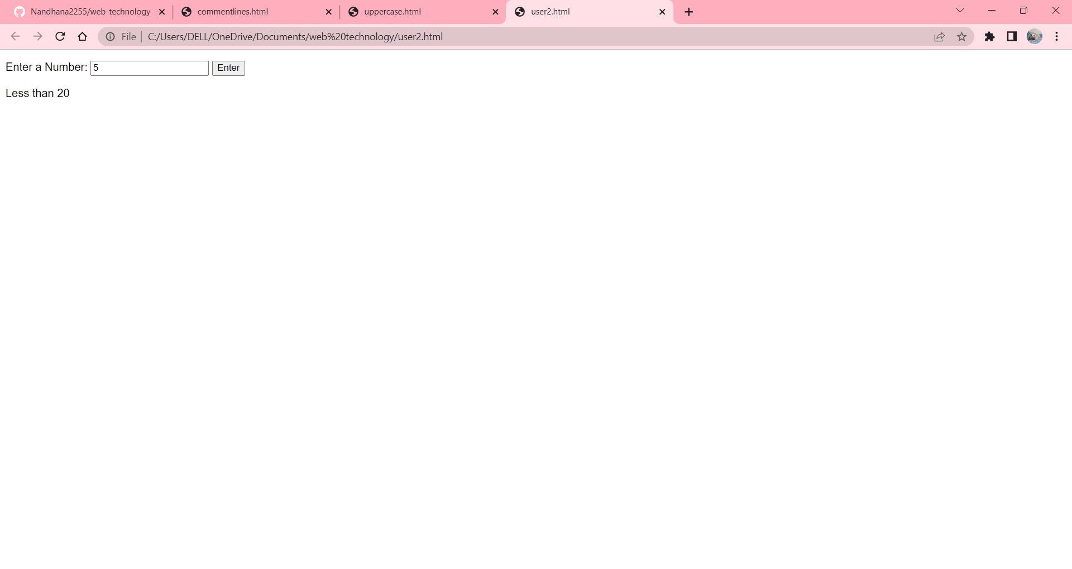

4.write a javascript to display current date and time.

Code:

<html>

<body>

<h2>Date and Time.</h2>

<div id="date"> </div>

<div id="time"> </div>

<script type="text/javascript">

let date = document.getElementById("date");

let time = document.getElementById("time");

let newDate = new Date();

let year = newDate.getFullYear();

let month = newDate.getMonth();

let todaySDate = newDate.getDate();

let hours = newDate.getHours();

let minutes = newDate.getMinutes();

let seconds = newDate.getSeconds();

date.innerHTML = " " + todaySDate + "/" + month + "/" + year;

time.innerHTML = hours+ ":" +minutes+ ":" +seconds;

</script>

</body>

</html>

Output:

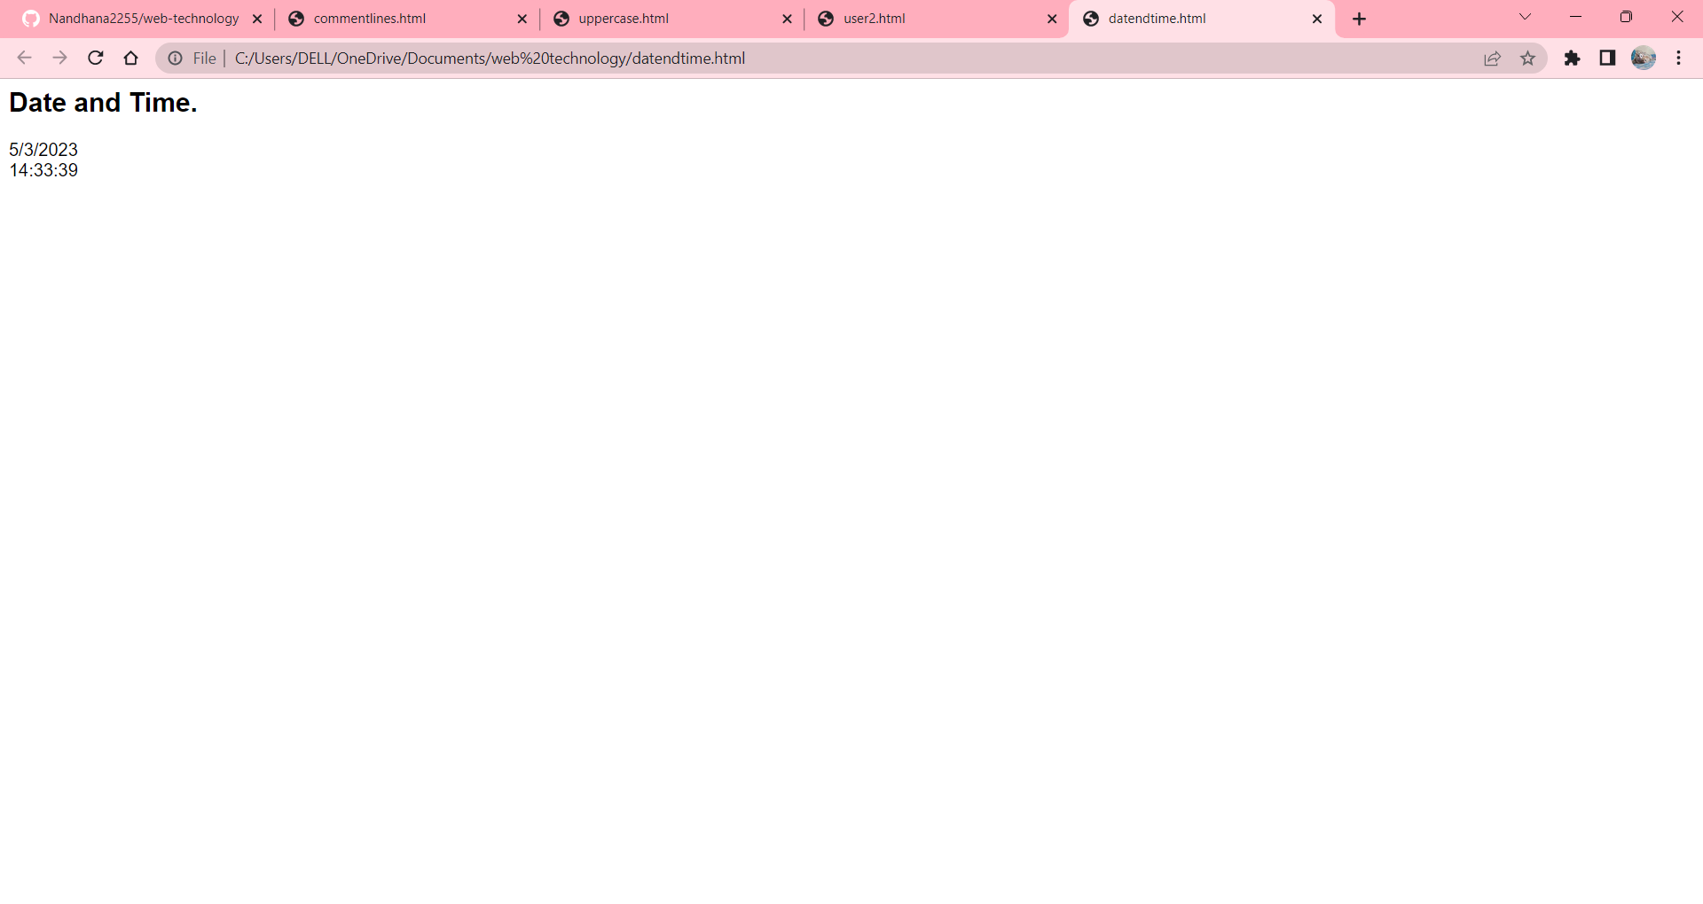

5.write a javascript to validate the email address.

Code:

<html>

<head>

<title>Email Validation</title>

<script>

function validateEmail() {

var email = document.getElementById("email").value;

var emailPattern = /^[a-zA-Z0-9._-]+@[a-zA-Z0-9.-]+\.[a-zA-Z]{2,}$/;

if (emailPattern.test(email)) {

alert("Valid email address!");

} else {

alert("Invalid email address!");

}

}

</script>

</head>

<body>

<h2>Email Validation</h2>

<input type="text" id="email" placeholder="Enter email address">

<button onclick="validateEmail()">Validate</button>

</body>

</html>

Output:

